**Synopsis**

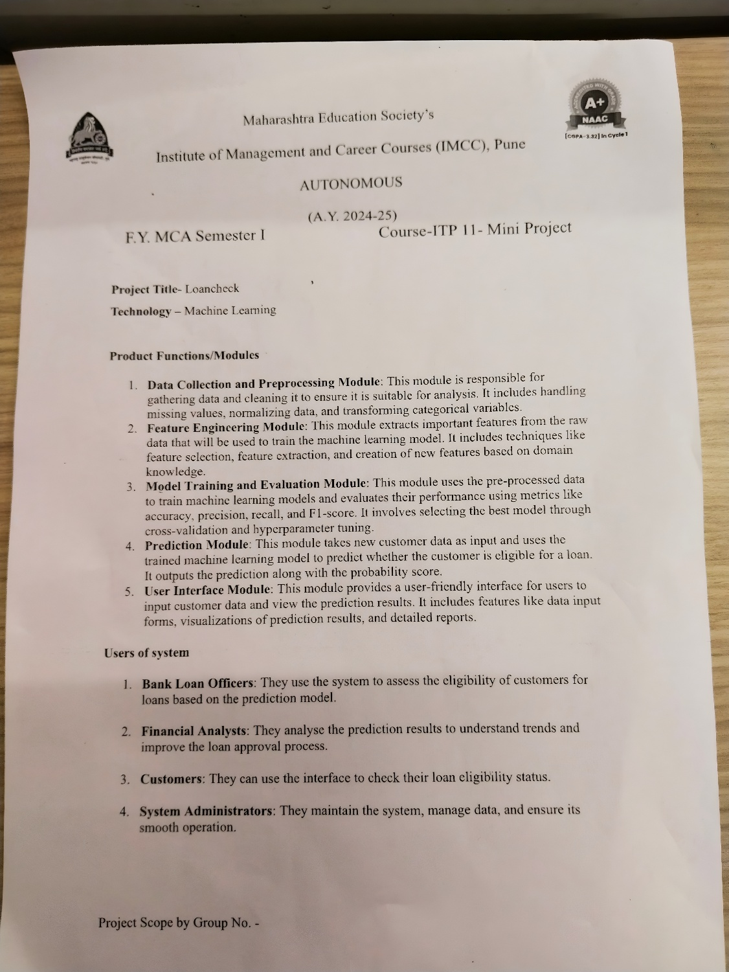

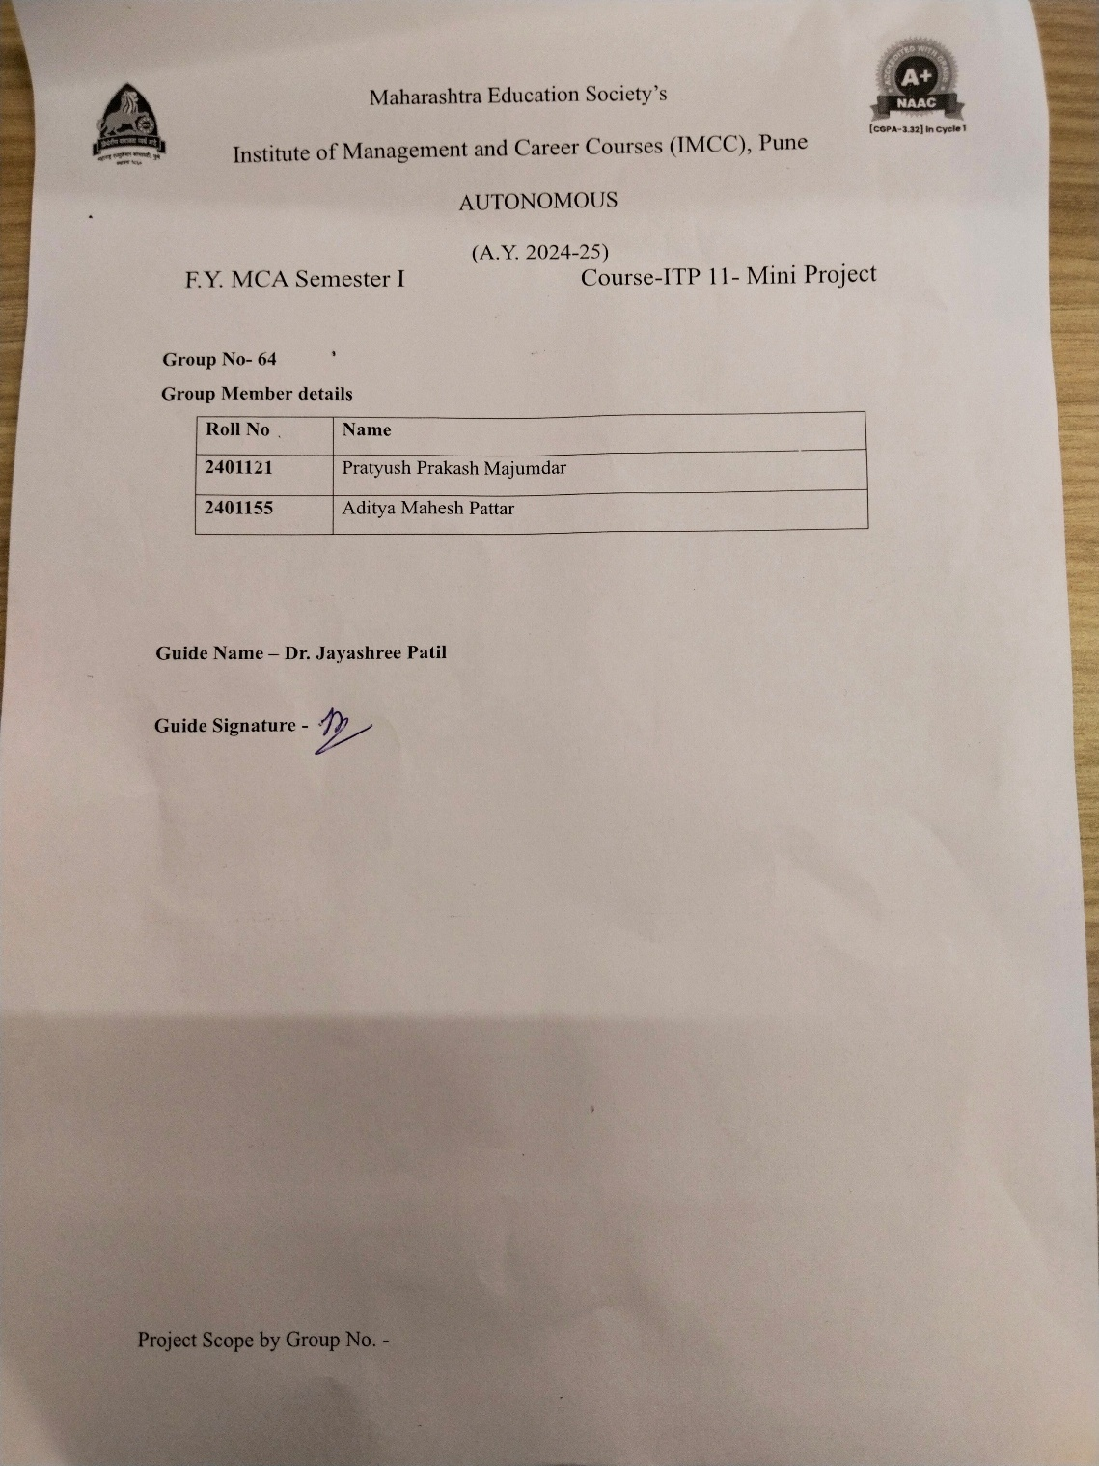

**Snapshots**

1. Prediction Page

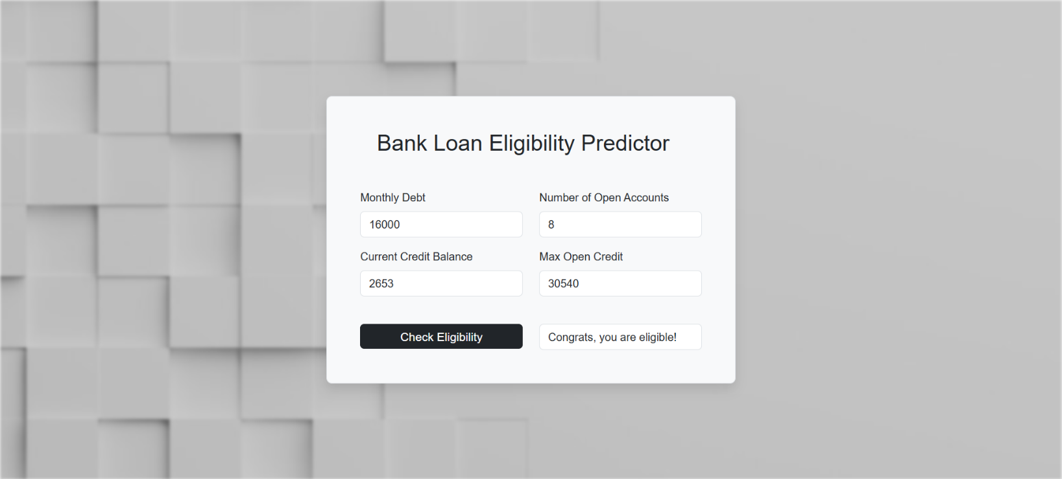

1. 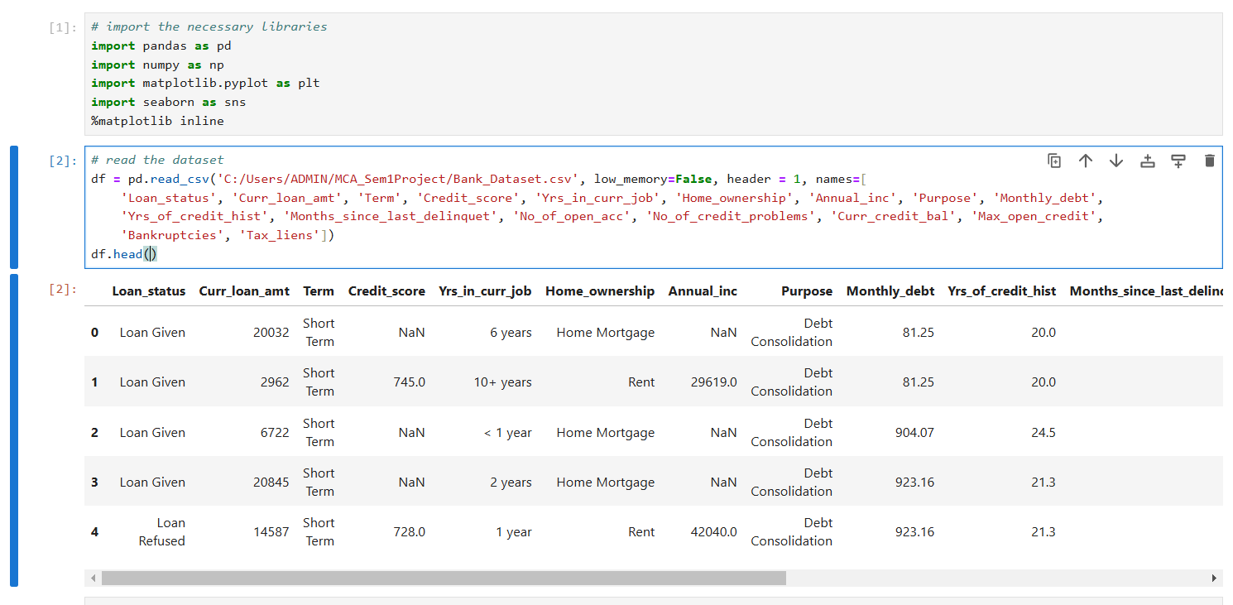Import libraries and read the dataset
2. 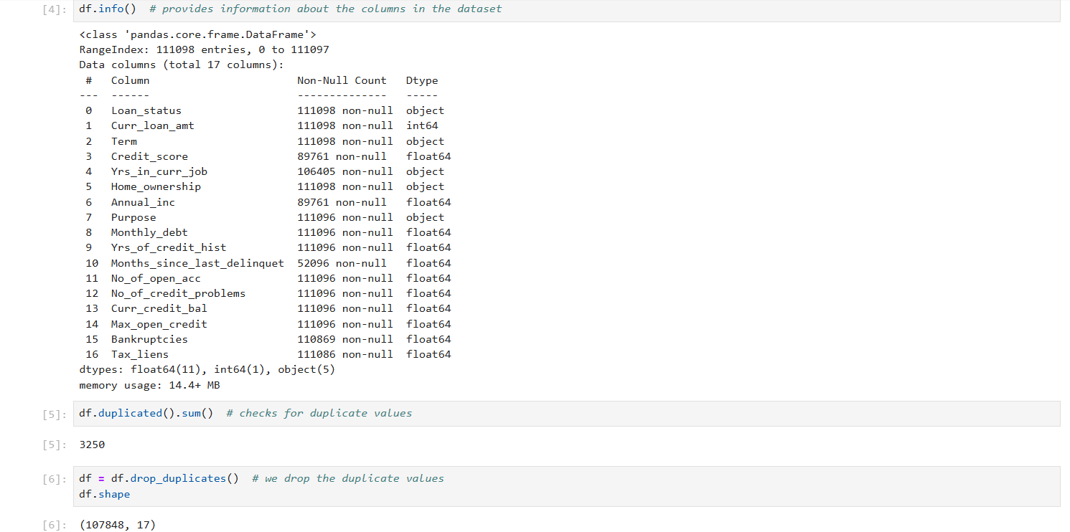Check info and duplicate values
3. 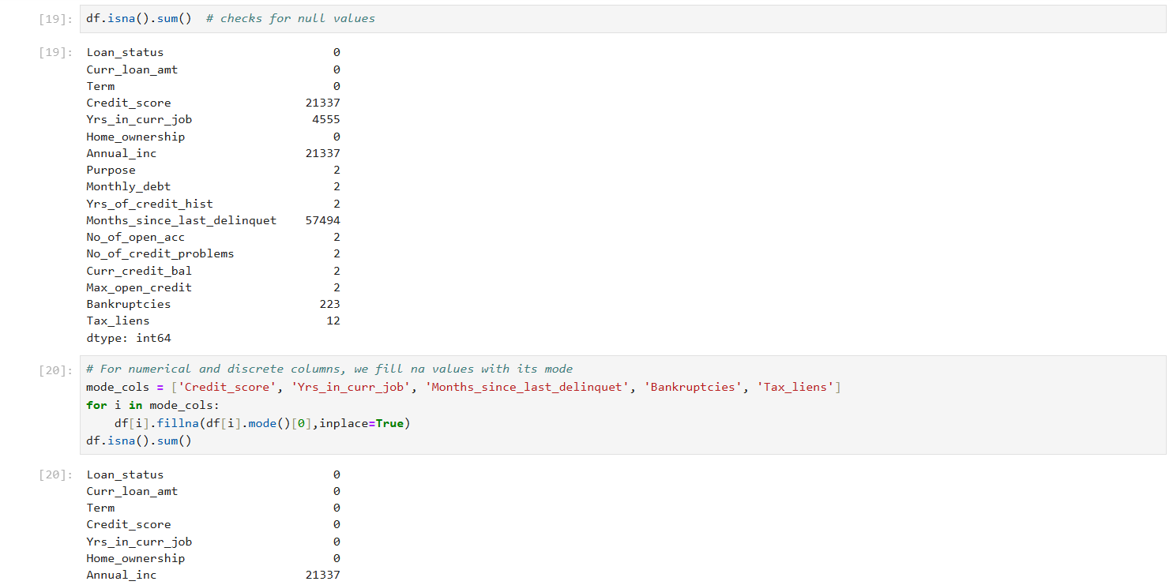Check and replace null values
4. 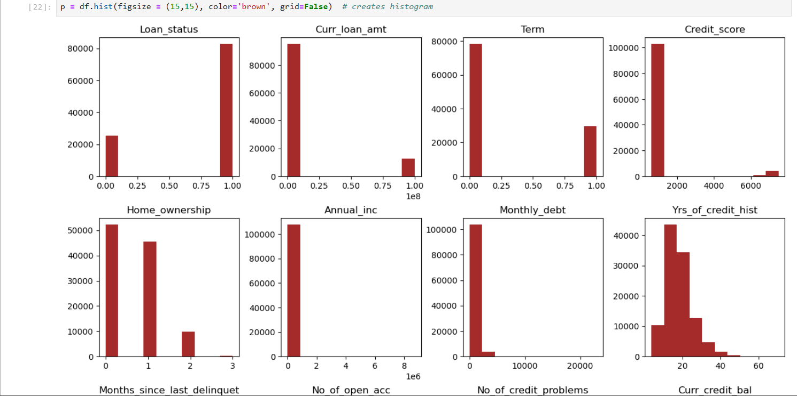Create histograms to check skewness of data

1. 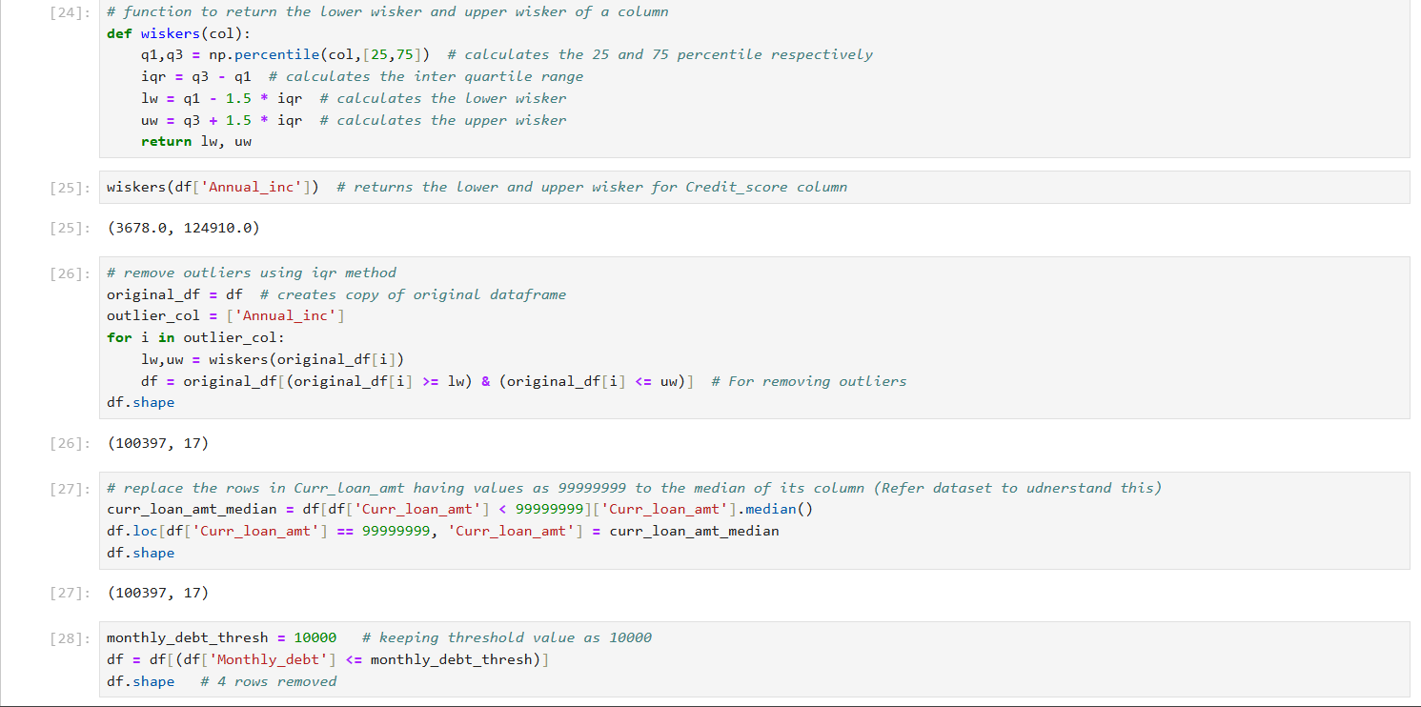Check and handle outliers

1. Perform factor analysis to find potential factors

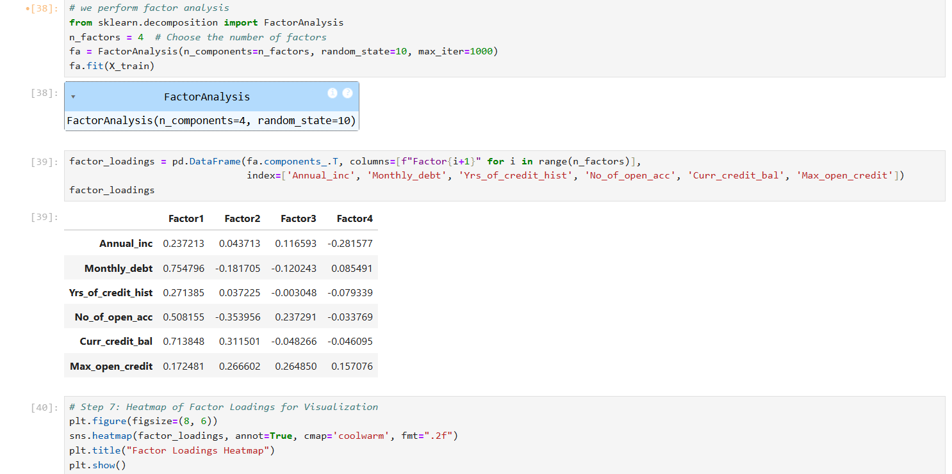

1. Heatmap to display the factor loadings

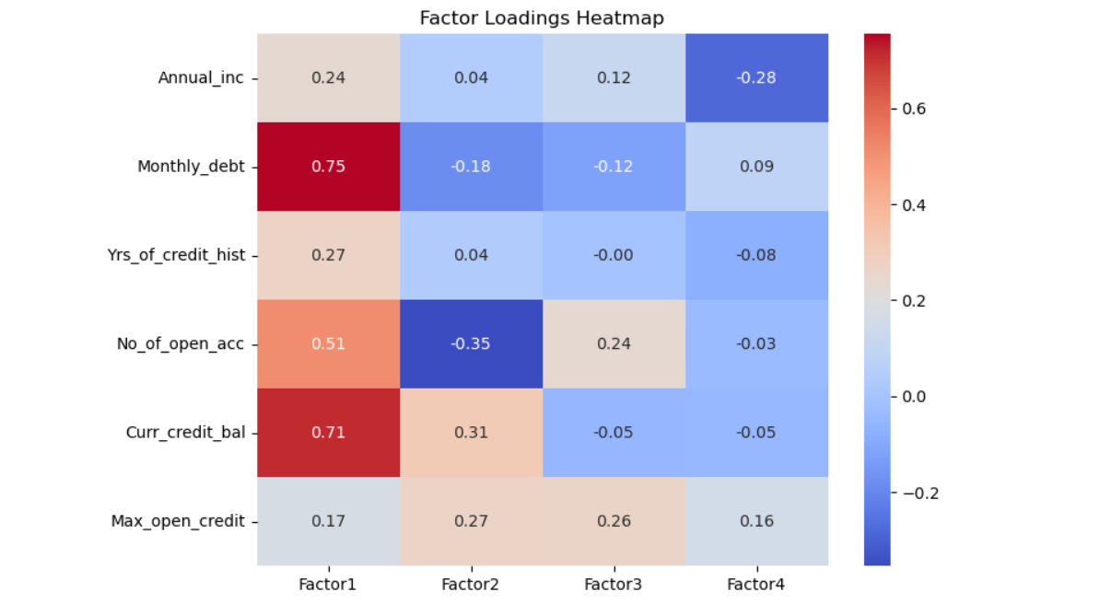

1. Find the best model for prediction

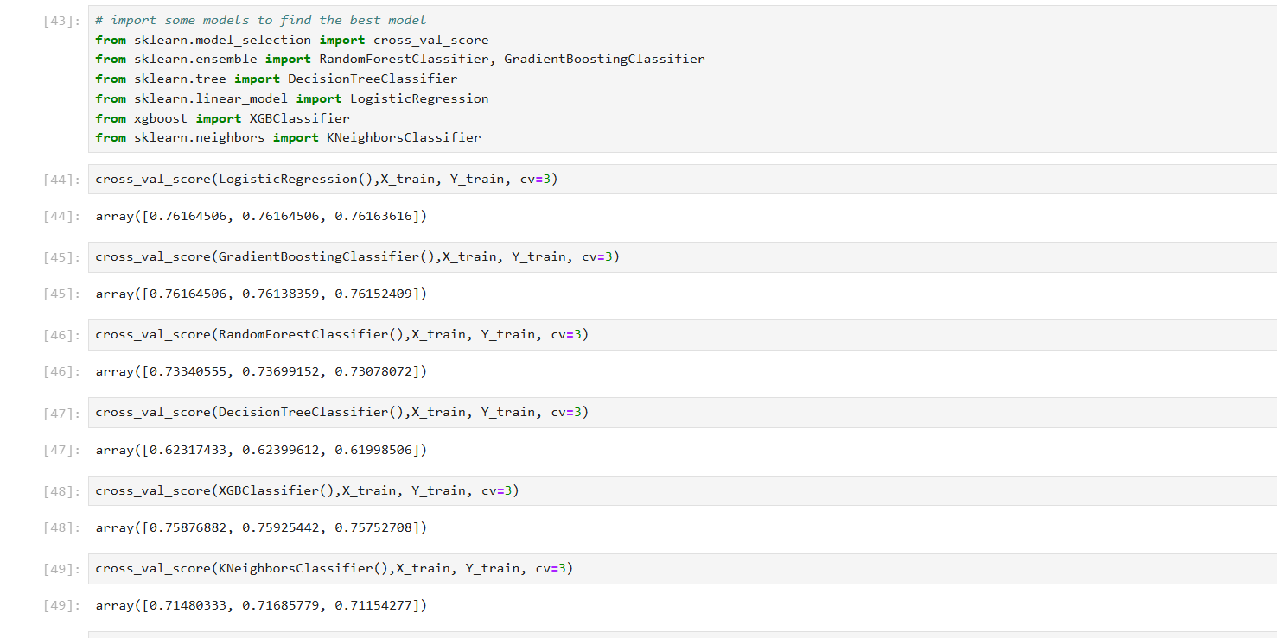

10) Calculate metrics.

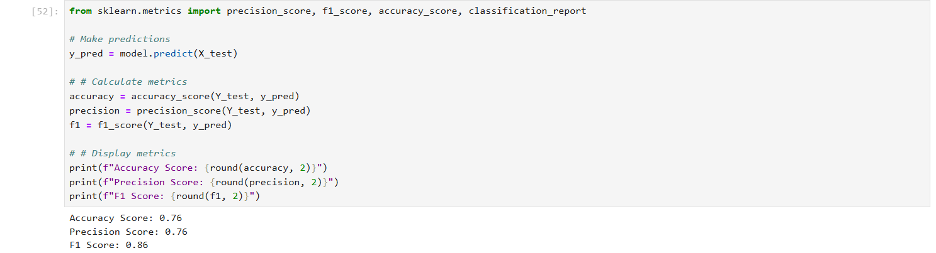

11) Store predictions in excel and pickle file

